# Table Of Contents

**Table Of Contents** **1**

**General** **3**

Finding a part in the component library 3

**Connectors** **3**

**Resistors** **4**

**Capacitors** **4**

**Microcontroller** **6**

Microcontroller selection 6

Supporting Hardware 7

Debug 7

LED 9

Oscillator 9

Power Supply 10

Communications 12

**Instructions for Creating a New Altium Project** **14**

Schematic and PCB file 14

PDF Export 14

Active BOM 14

Github and gitignore 14

**PCB Layout** **15**

ESD Protection 15

CAN Connectors 15

TVS diodes: 15

**Best Practices and Design Reviews** **18**

Schematic 18

PCB 18

**Preparing to Order** **19**

**References** **20**

# 

# General

## Finding a part in the component library

The easiest way to find a part is to search by the AUVIC component ID. When searching by component ID, if there are multiple results, ensure that the latest revision is used. The 1 to 2 digit number after the last hyphen is the revision number. Component IDs listed in this document do not contain the revision number. The number will appear when searching in Altium.

# Connectors

Table 1 shows AUVIC’s standard connectors. It should be used whenever possible. Avoid using terminal blocks unless it benefits the design or the standard connectors are not satisfactory. When placing a parts order for your board, ensure that the other end of any connector used is also added to the order.

| **Standard Connectors List** | | | | |
| --- | --- | --- | --- | --- |
| Purpose | Description | Digikey Part Number | AUVIC Component ID | Price |
| Power | | | | |
| Power < 10A | Connector Header Through Hole, Right Angle 4 position 0.118" (3.00mm) | WM1820-ND | CMP-005-0021 | $2.24 |
| Power < 5A | Connector Header Through Hole, Right Angle 2 position 0.118" (3.00mm) | WM1819-ND | CMP-00001 | $1.48 |
| Power < 69A | Connector Header Through Hole, Right Angle 6 position 0.224" (5.70mm) | WM11971-ND | CMP-00049 | $3.50 |
| Power < 92A | Connector Header Through Hole, Right Angle 8 position 0.224" (5.70mm) | WM11972-ND | CMP-00051 | $4.18 |
| Data, Data + Power | | | | |
| 2 Pin Data | Connector Header Through Hole, Right Angle 2 position 0.100" (2.54mm) | A33855-ND | CMP-00010 | $2.18 |
| 4 Pin Data,  2 Pin Data + Power < 2A | Connector Header Through Hole, Right Angle 4 position 0.100" (2.54mm) | A33860-ND | CMP-005-0029 | $1.63 |
| 3 Pin Data | Connector Header Through Hole, Right Angle 2 position 0.100" (2.54mm) | A32563-ND | CMP-00099-4 | $2.05 |

Table 1: Standard Connectors

# Resistors

1. **Use SMD resistors** unless absolutely necessary for the design
2. **Use 0603 sized resistors** for SMD unless the power dissipation requirements are higher.   
   0603 is small but still easy to solder. If we stick to a standard size, it becomes easier to keep resistors in stock
3. **Use only 1% resistors** unless a higher precision is required. In a production design, 5% would be used to save money since higher precision resistors cost more. However, since we only build a few boards, the cost savings does not outweigh the disadvantages. If all resistors in a board are the same tolerance, we don’t have to order multiple parts for the same resistance. It also becomes easier to keep resistors in stock.

# Capacitors

1. **Use SMD capacitors** unless absolutely necessary for the design. When using large capacitors (>100uF), you may choose to place multiple smaller capacitors in parallel instead of placing one large capacitor.
2. It is recommended to **use 0603 and 0805** sizes for small value ceramic capacitors like bypass capacitors. Try to use the smaller of the two if you have an option.

| **Standard Capacitors List** | | | |
| --- | --- | --- | --- |
| Capacitor | Usage | AUVIC Component ID | Digi-Key PN |
| 1nF Ceramic | Filters | CMP-00018 | 1276-1018-2-ND |
| 150nF Ceramic | Bypass cap, filters | CMP-00020 | 1276-6476-1-ND |
| 100nF Ceramic | Bypass cap, filters | CMP-00000 | 1276-1033-1-ND |
| 1uF Ceramic | Bypass cap, filters | CMP-00005 | 1276-6470-1-ND |
| 4.7uF | Bypass cap, filters | CMP-00019 | 1276-2789-1-ND |
| 10uF Ceramic | Bypass cap, filters | CMP-00004 | 1276-6767-1-ND |

Table 2: Standard Capacitors

# 

# Microcontroller

This section details the hardware requirements if using a microcontroller in your design.

## Microcontroller selection

AUVIC has moved to using the same microcontroller for all designs with a few exceptions. This was done in an effort to simplify firmware development. The STM32F413xG has been determined to be the best controller to use. The table 3 lists the variants you can choose from for your design. ST provides an 81-pin package, but due to the complexity of the footprint, this variant should not be used for new designs.

| **Microcontroller List** | | | |
| --- | --- | --- | --- |
| General Purpose | | | |
| MFG PN | Description | AUVIC Component ID | Digi-Key PN |
| STM32F413VGT6 | 100-pin LQFP, 1Mbyte Flash  320KB RAM 100 MHz CPU | CMP-00007 |  |
| STM32F413RGT6 | 64-pin LQFP,  1Mbyte Flash  320KB RAM 100 MHz CPU | CMP-00006 |  |
| STM32F413ZGT6 | 144-pin LQFP, 1Mbyte Flash  320KB RAM 100 MHz CPU |  |  |
| Special Purpose | | | |
| STM32F429VGT6 | For high performance or special peripheral requirements only  100-pin LQPF, 1Mbyte Flash  256+4KB RAM 180 MHz CPU | CMP-00008 |  |
| ~~STM32F042F4P6TR~~ | ~~For simple boards only.~~  ~~32-bit 48MHz 16kB (16k x8) Flash 20-TSSOP~~ |  | ~~497-19320-1-ND~~ |

Table 3: List of approved microcontrollers

## Supporting Hardware

### Debug

All boards need to have a debug header that will connect to a ST debugger. This is how we flash new firmware to the boards and attach a debugger to step through code. The header also has UART for debugging which must be connected to UART capable pins on the microcontroller. It is recommended to connect RX to PD9 and TX to PD8 since these pins are connected to the ST-Link VCP pins on the Nucleo board. However, this is not a hard requirement. Note that the SWCLK, SWDIO, SWO, and NRST connect to specific pins on the STM microcontroller you are using (check the datasheet to make sure you are connecting to the right pin). The 5V pin must be connected to the board’s internal 5V through a schottky diode. This allows the debugger to power the microcontroller. See figure 1 and table 4 for reference.

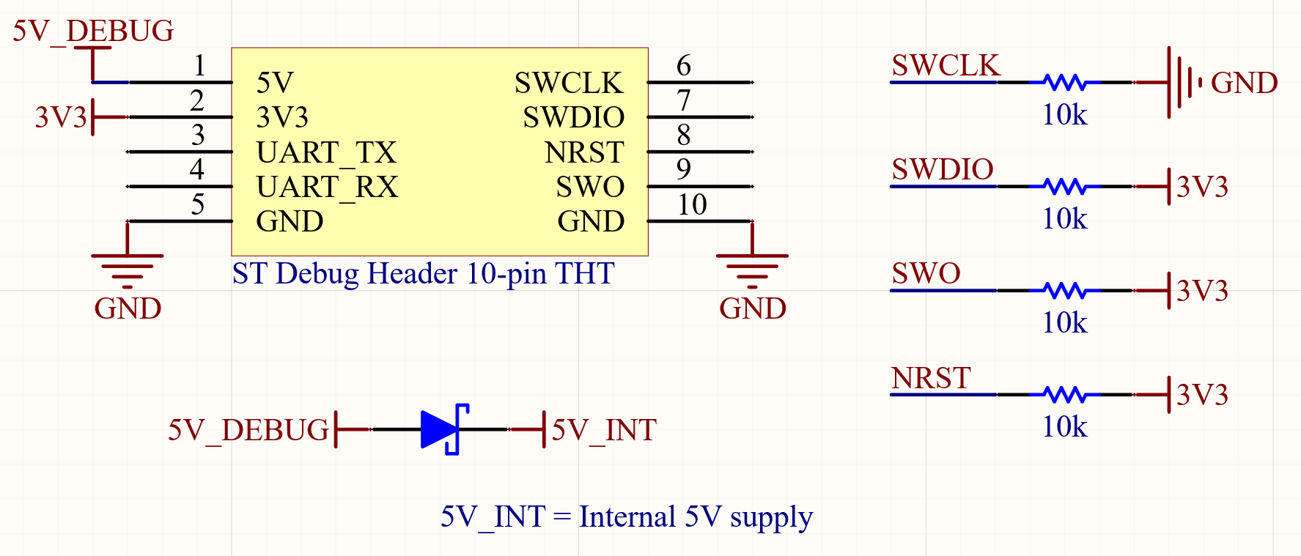

Figure 1: Microcontroller debug header schematic

| Part | AUVIC Component ID |
| --- | --- |
| Header THT | CMP-00011 |
| Header SMD | CMP-00013 |
| Schottky Diode | CMP-057-0000 |
| 10kR Resistor | CMP-047-0013-1 |

Table 4: Microcontroller debug header component list

Another debug feature that all boards will have to incorporate are reset buttons to manually reset the STM microcontroller, and a boot header that allows the user to force the STM microcontroller into boot mode. See figure 2 and table 5 for reference.

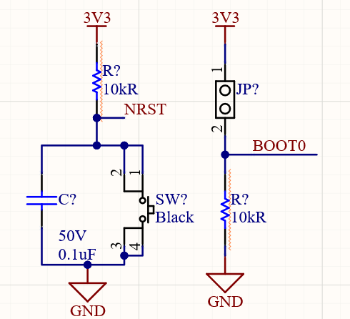

Figure 2: Microcontroller External Reset and Boot Schematic

| Part | AUVIC Component ID |
| --- | --- |
| Switch SMD (option 1) | CMP-00077-1 |
| 0.1uF Capacitor | CMP-00000-3 |
| 2 pin Header | CMP-004-0001-1 |
| 10kR Resistor | CMP-047-0013-1 |
| CMP-00104-1 (option 2) | CMP-00104-1 |

Table 5: Microcontroller External Reset and Boot component list

### LED

LEDs should be connected to the microcontroller’s GPIOs to help with debugging. The more LEDs the better, but 3 is the recommended number. It is recommended to connect the LEDs to PB0(green), PB7(blue), and PB14(red) since these pins are connected to LEDs on the Nucleo board. However, this is not a hard requirement. Use one red LED, one green LED and one blue LED. The table below shows the LED part number and recommended resistor values.

| Part | AUVIC Component ID | Forward Voltage | Recommended Resistor, IF=4mA | | | |
| --- | --- | --- | --- | --- | --- | --- |
| Vin = 3.3V | Vin = 5V | Vin = 12V | Vin = VBatt |
| Red LED | CMP-00066 | 2V | 330Ω | 750Ω | 2.49kΩ | 6.49kΩ |
| Green LED | CMP-00064 | 2.85V | 110Ω | 536Ω | 2.26kΩ | 6.34kΩ |
| Blue LED | CMP-00063 | 2.85V | 110Ω | 536Ω | 2.26kΩ | 6.34kΩ |
| Orange LED | CMP-00065 | 2V | 330Ω | 750Ω | 2.49kΩ | 6.49kΩ |

Table x: LED component list and recommended resistor value

### Oscillator

If your design requires an accurate clock, you must add the circuit below to your schematic. For example, the motor controller’s RPM feedback requires an accurate clock because it compares the time between two rising edges of the motor back emf. However, if your board has space it is always recommended to add this so that the option of enabling it later is available. See figure 3 and table 5 for reference.

| Part | AUVIC Component ID |
| --- | --- |
| 8 Mhz  Oscillator | CMP-00079-2 |
| 16pF Cap | CMP-00087-2 |

Table 5: Microcontroller oscillator component list

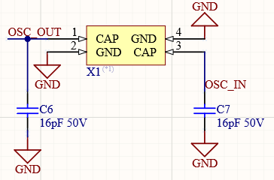

Figure 3: Microcontroller external oscillator schematic

### Power Supply

The STM microcontrollers can operate with a supply voltage of 1.8V to 3.6V [1]. AUVIC’s designs should operate the controllers using a 3.3V supply. It is recommended to use a 3.3V linear regulator with a input voltage of 5V. See figure X and table X for reference. All boards should take 5V from the power board’s 5V rail.

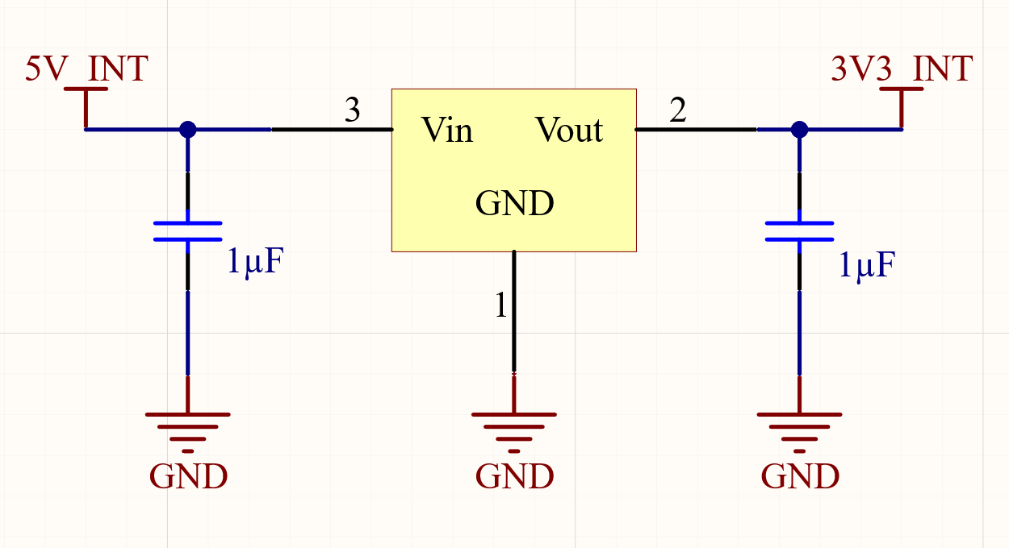

| Part | AUVIC Component ID |
| --- | --- |
| LDO | CMP-00003 |
| 1uF Cap | CMP-00005 |

Table x: Component list for 3V3 rail

Figure x: Schematic for 3V rail

Appropriate bypass capacitors must be used.

* One 10uF ceramic or tantalum capacitor per chip
* One 0.1uF ceramic capacitor per VDD pin
* If VBAT is not being supplied by a separate battery, it should be connected to VDD with a 0.1uF ceramic decoupling capacitor. This will be the case for AUVIC’s boards unless we build a board with a built in battery.
* One 0.1uF and one 1uF ceramic capacitor per VDDA pin. 3.3V should be connected to the VDDA/VREF+ pin through a ferrite bead
* One 2.2uF low ESR ceramic capacitor per VCAP pin. There should be two VCAP pins. This is required if using the internal regulator on the microcontroller which is the case for AUVIC’s designs.

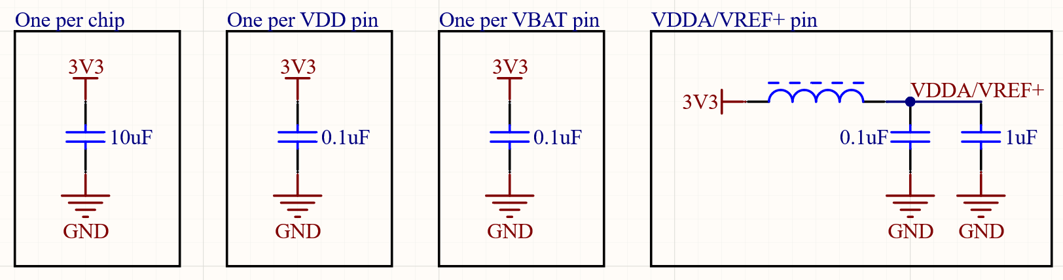

Figure xa: Microcontroller bypass capacitor schematic

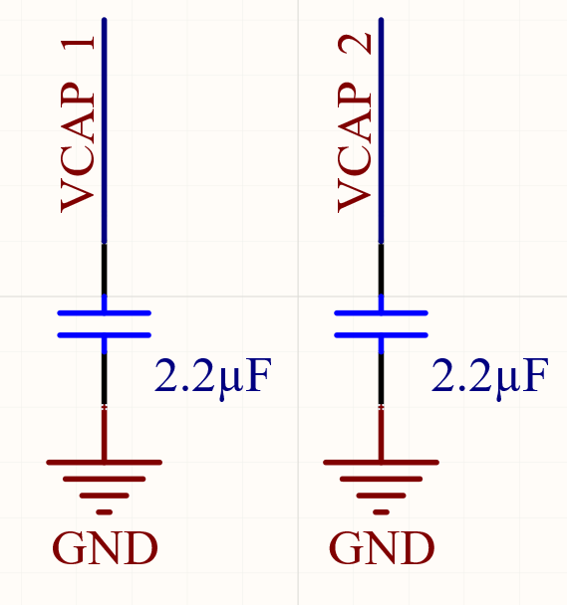

| Part | AUVIC Component ID |
| --- | --- |
| 0.1uF Cap | CMP-00000 |
| 1uF Cap | CMP-00005 |
| 10uF Cap | CMP-00004 |
| Ferrite bead | CMP-00016 |
| 2.2uF Cap | CMP-006-0030 |

Table x: Microcontroller bypass capacitor component list

Figure xb: Microcontroller bypass capacitor schematic

For a more detailed explanation on the power supply requirements of the STM32F4 series microcontrollers, read cited text number 1.

## Communications

All AUVIC controllers will use CAN to communicate. CAN 2.0 operating at 500kbps will be used. See figure x for a reference design. The CAN_H and CAN_L lines must have a differential pair directive added in Altium to ensure the trace length on the PCB are the same. The CAN_TX and CAN_RX pins should be connected to CAN capable pins on the microcontroller. Choose CAN1 or CAN2 if possible. The CAN_STB pin should connect to a GPIO on the microcontroller. The 120Ω terminating resistor should be present in your schematic, but should only be populated if your component will be terminating the CAN bus. There will only be two devices per bus at either end of the bus. The TVS diode should be present in your schematic, but should not be populated unless deemed necessary after testing.

Note: This circuit is still under test and could change. A TVS diode and common mode choke might be added. Any board that uses this design should **not** be fabricated until this circuit has completed the required testing.

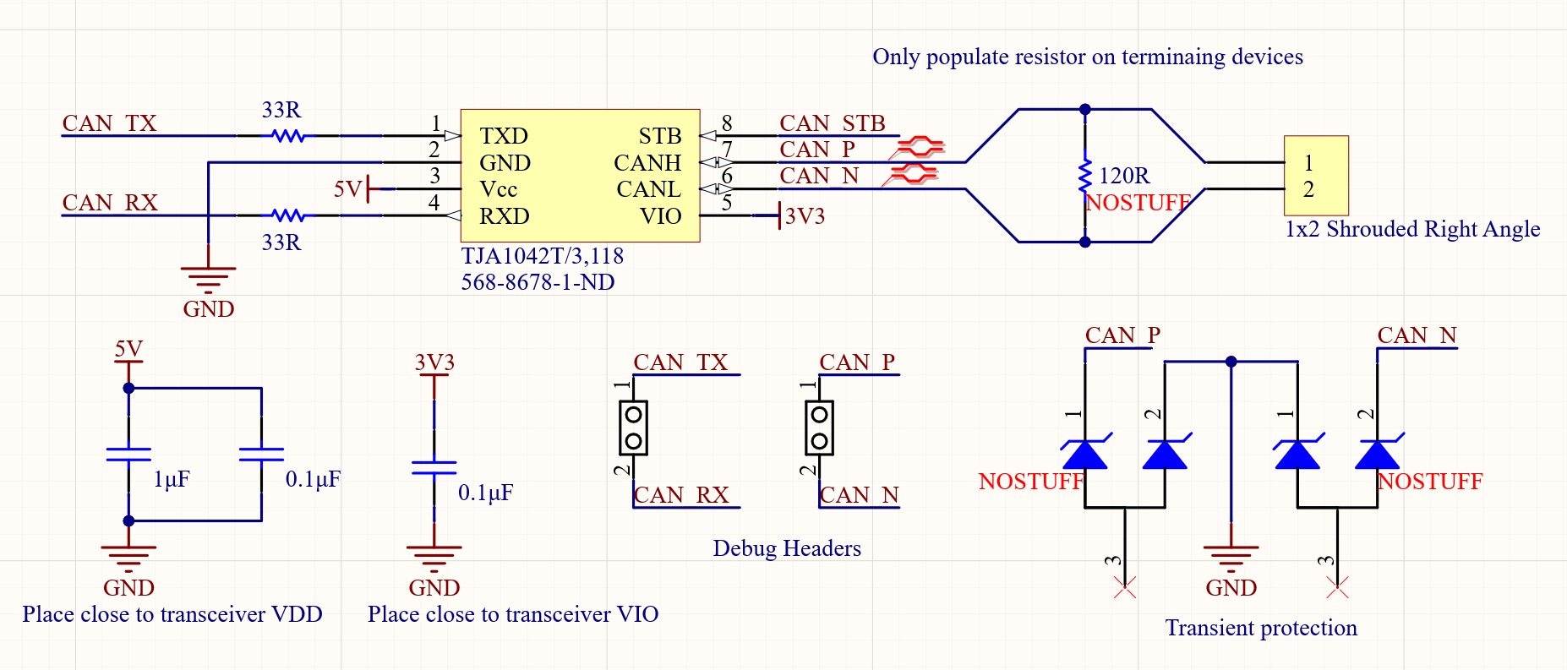

Figure x: CAN transceiver reference schematic

| Part | AUVIC Component ID |
| --- | --- |
| CAN Transceiver | CMP-032-0000 |
| 2-pin Connector | CMP-00010 |
| 2-pin Header | CMP-004-0001 |
| TVS Diode | CMP-058-0000 |
| 0.1uF | CMP-00000 |
| 1uF | CMP-00005 |
| 120 Ohm Resistor | CMP-00061 |
| 33 Ohm Resistor | CMP-00060 |

Table x: CAN transceiver schematic component list

# Instructions for Creating a New Altium Project

## Schematic and PCB file

## PDF Export

Use the same .OutJob file for everything. Naming convention.

## Active BOM

Currency, supplier part number under one column.

## Github and gitignore

Blah

Don’t upload history and project output files

## 

# PCB Layout

The following sections will give recommendations for PCB layouts.

## ESD Protection

Electrostatic Discharge is the sudden flow of electricity between two charged objects. Testing for ESD on a prototype PCB requires the use of an ESD Gun, however these are expensive. The following subsections provide layout tips to lower the occurrence of ESD.

### CAN Connectors

*AND8169/D EMI/ESD Protection Solutions for the CAN Bus* by ON Semiconductor gives the following guidelines on ESD protection:

1. Locate the protection devices (TVS or diode) as close as possible to the I/O connector. This absorbs transient voltage before it couples to adjacent traces.
2. Minimize the loop area for the high-speed data lines, power and ground lines to reduce the radiated emissions and RF noise.
3. Minimize path length between CAN signal lines and protective devices.
4. Use ground planes whenever possible to reduce parasitic capacitance and inductance.

### TVS diodes:

Protects a transceiver by clamping a surge voltage to a safe level.

* + Pros: High Z below breakdown voltage and low Z above breakdown voltage. Optimized to absorb peak energy of transient voltages.
  + Cons: May clamp the CAN_L and CAN_H waveforms if a common mode or offset voltage exists.
  + Chosen TVS diode**: PESD36VS2UT**

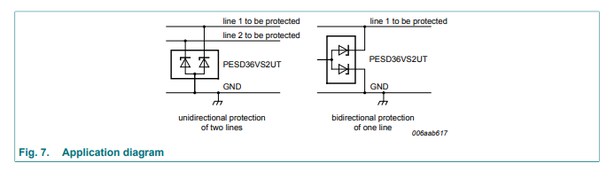

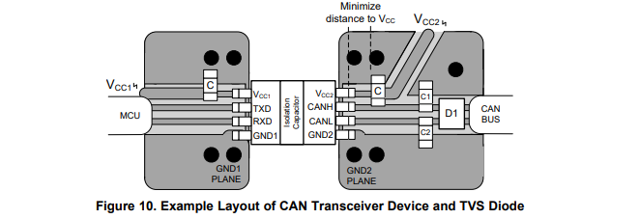

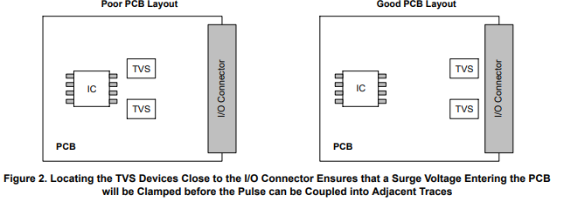

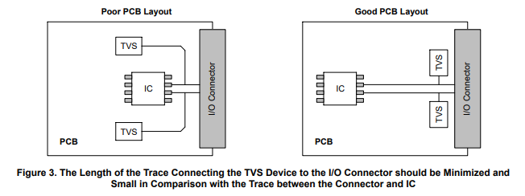

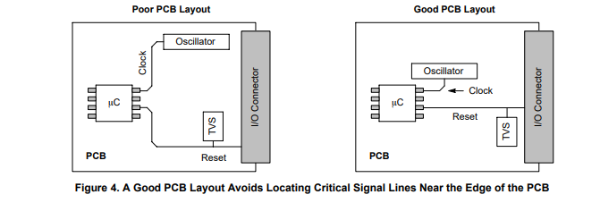

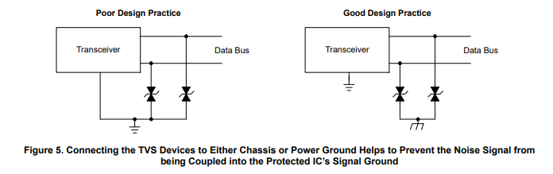

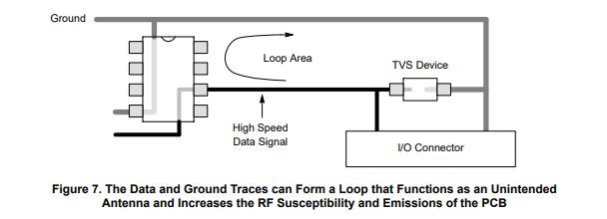

# Best Practices and Design Reviews

## Schematic

1. Be wary of logic levels on STM32 (5V tolerant etc)
2. Ensure correct resistors for LEDs

## PCB

1. Make sure vias are not directly under silkscreen designators or they will not print correctly
2. Use lower density component footprints
3. Double check bypass cap requirements for ICs
4. Place connectors at edge of board oriented away from center of board
5. Place designators so that when letters are upright the corresponding component is below
6. Vias: tent all vias and set to direct connect in thermal relief
7. Remove unnecessary bends in traces

<https://www.ti.com/lit/an/szza009/szza009.pdf?ts=1610821093742&ref_url=https%253A%252F%252Fwww.google.com%252F>

<https://www.allaboutcircuits.com/technical-articles/practical-pcb-layout-tips/>

<https://www.allaboutcircuits.com/technical-articles/common-layer-stack-ups-for-a-four-layer-board/>

<https://resources.altium.com/p/top-5-pcb-design-guidelines-every-pcb-designer-needs-know>

The above are good resources for PCB best practices

Set Design rules to the following:

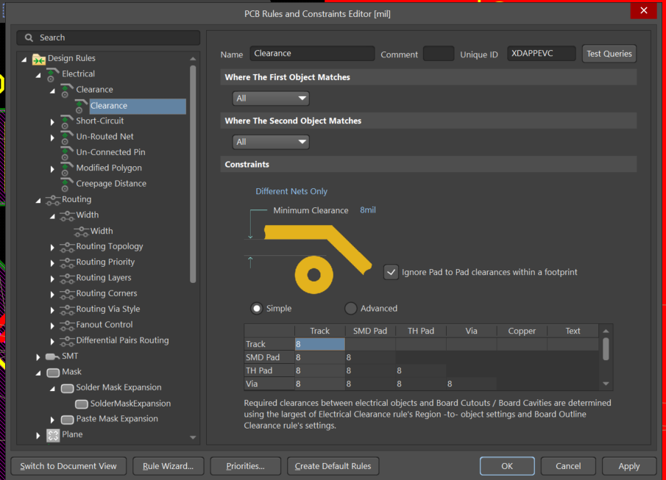

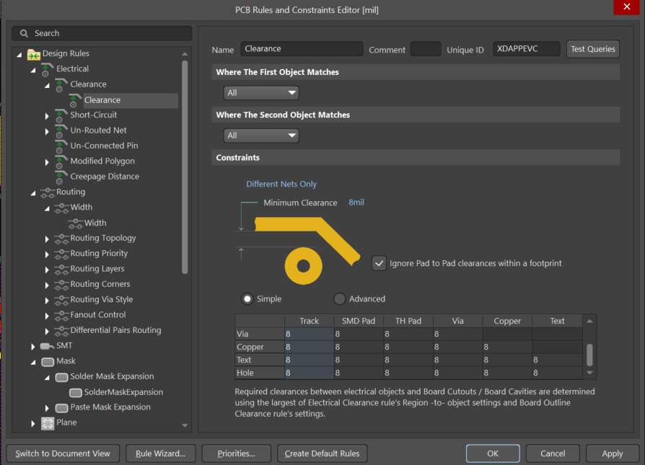

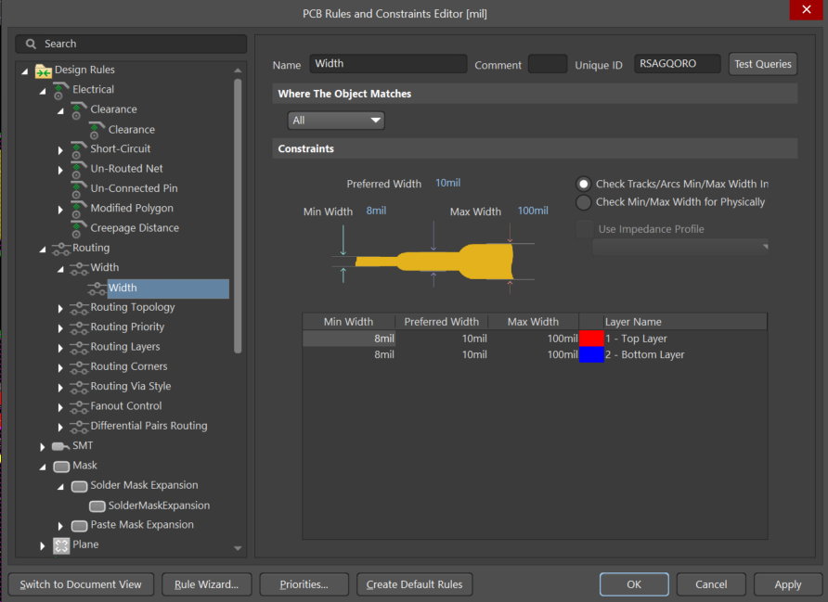

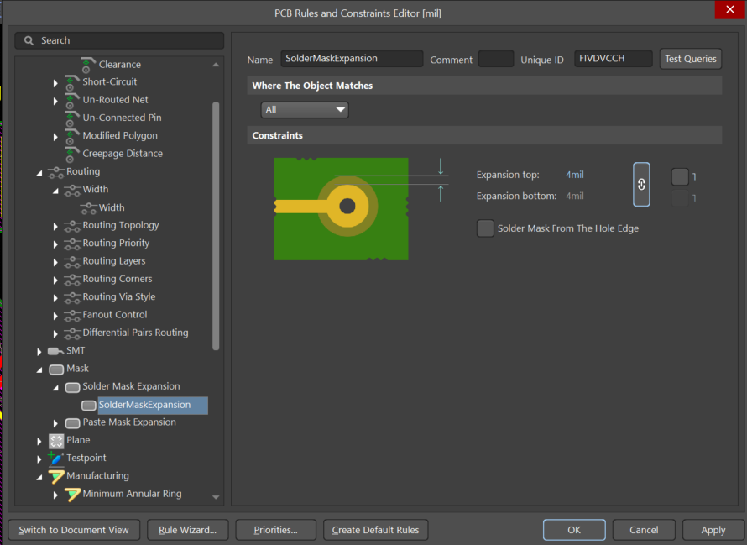

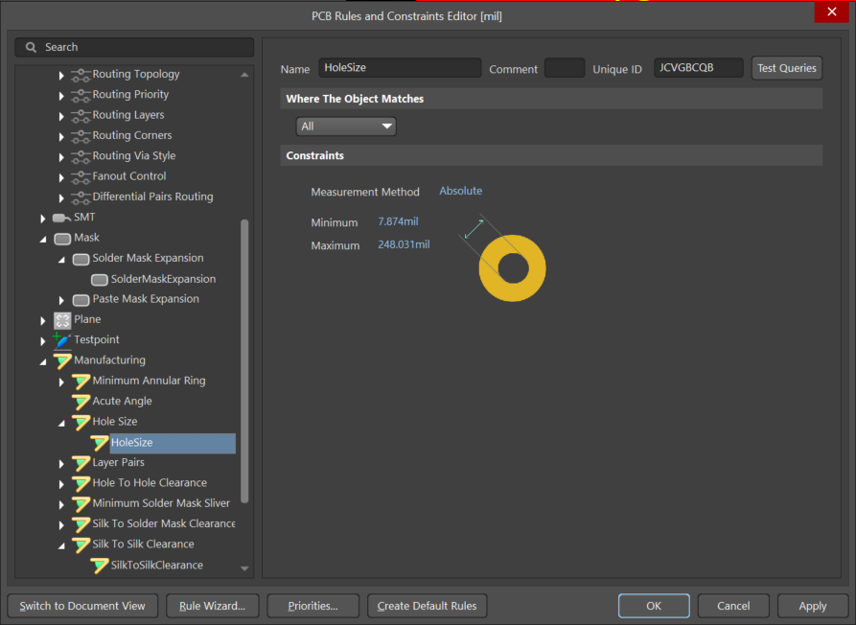

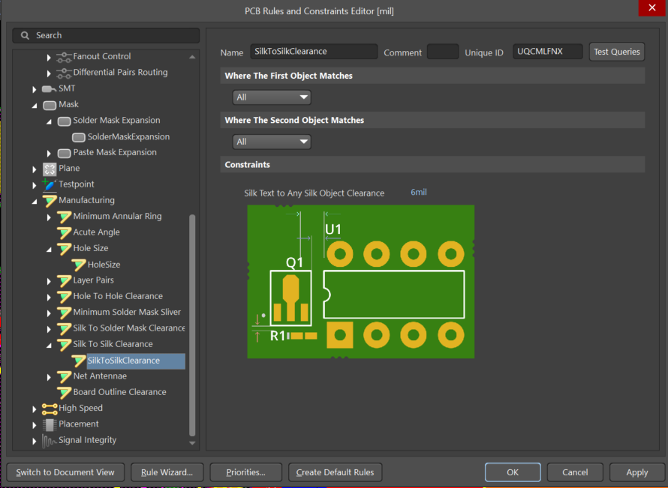

# 

# Preparing to Order

1. Make a keepout layer
   1. Go to Keepout Layer (bottom tab)
   2. Draw lines around board edge
   3. Ensure polygon pours are in line with or greater than keepout area and repour
2. Open Settings folder-> Open Output Job Files -> Open PCBname.OutJob
3. Add New Output Container
   1. New Folder Structure
   2. Name it “Fabrication”
4. In Fabrication Outputs
   1. Add Gerber and NC Drill files and configure(by double clicking) based on instructions here: <https://support.jlcpcb.com/article/42-how-to-export-altium-pcb-to-gerber-files>
   2. *ignore drill drawing tab
5. Click enabled and link to Fabrication Folder
6. Add New Output Container
   1. New Folder Structure
   2. Name it “Step”
7. In Export Outputs
   1. Add Step file
8. Click enabled and link to Step Folder
9. Add New Output Container
   1. New Folder Structure
   2. Name it “BOM”
10. In Report Outputs
    1. Add Project BOM
11. Click enabled and link to Report Folder
12. Click generate content in all output containers

# 

# References

[1] <https://www.st.com/resource/en/application_note/dm00115714-getting-started-with-stm32f4xxxx-mcu-hardware-development-stmicroelectronics.pdf>

[2]

<https://assets.nexperia.com/documents/data-sheet/PESD36VS2UT.pdf>